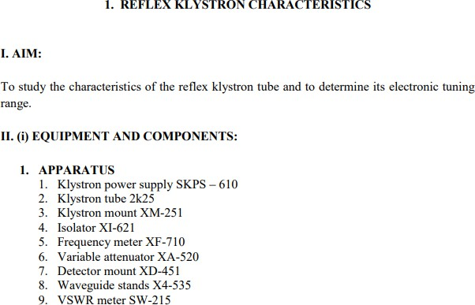

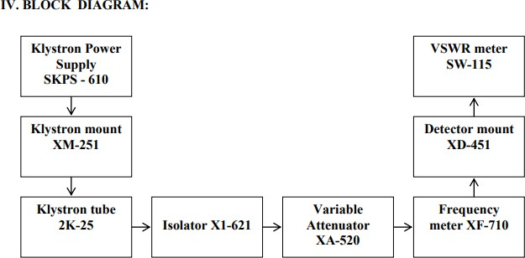

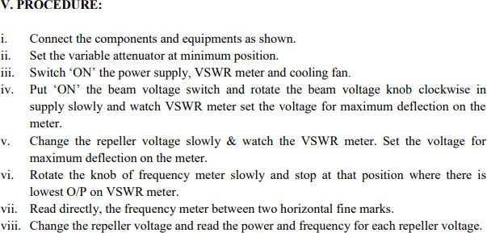

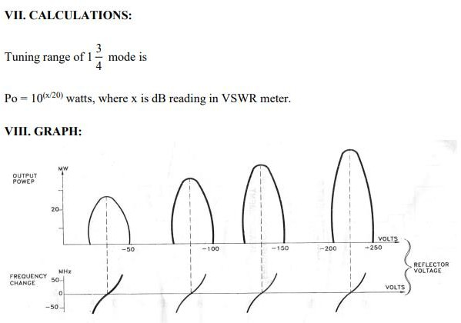

**TABULATION**

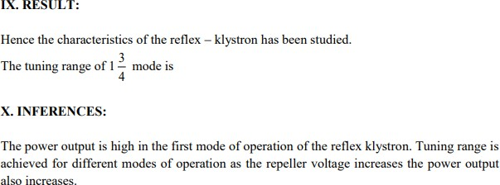

## EXP NO: 2 STUDY OF POWER DISTRIBUTION IN DIRECTIONAL COUPLER

**OBJECTIVE**

To study the power distribution in various ports of directional coupler and measure the following parameters:

1. Insertion loss
2. Coupling factor
3. Directivity

And also design a multi hole directional coupler to find its directivity.

## HARDWARE REQUIRED

Klystron power supply, Klystron with mount, Isolator, variable attenuator, CRO, Directional Coupler, Matched termination

## INTRODUCTION

A directional coupler is a hybrid waveguide joint, which couple power in an auxiliary waveguide arm in one direction. It is a four-port device but one of the ports is terminated into a matched load (Refer figure 1).

### Characteristics of a Directional Coupler

An ideal directional coupler has the following characteristics

1. If power is fed into port (1) the power is coupled in ports (2) and (3) i.e., power flows in the forward direction of the auxiliary arm port (3) but no power couples in port (4) i.e., in backward direction. Similarly power fed in (2) couples into ports (1) and (4) and not in (3).
2. All the four ports are matched, i.e. if three of them are terminated in matched loads, the fourth is automatically terminated in a matched load.
3. If power couples in reverse direction, power fed in (1) appears in ports (2) and

(4) and nothing in (3), then such type of coupler is known as backward directional coupler. The conclusion is that in the auxiliary section the power is coupled in only one direction.

We will measure coupling coefficient, directivity and the main line insertion loss as a function of frequency.

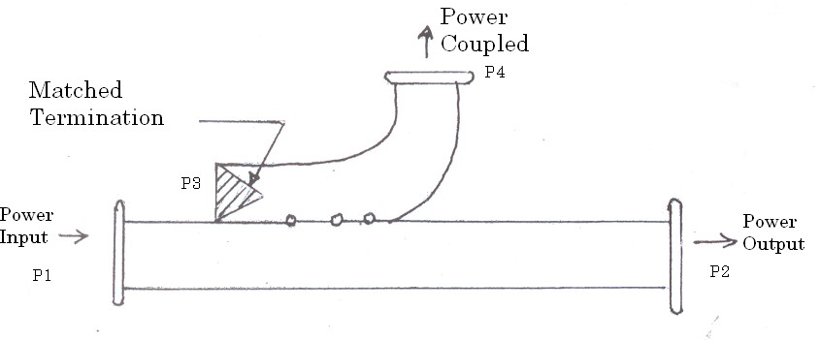

**Figure 1: Directional coupler as a three – port device: Uni directional coupler**

## PRELAB QUESTIONS

1. How does power couple in directional coupler.
2. Give the applications of directional coupler
3. What is the purpose of measuring directivity, coupling factor?
4. Give the S matrix for directional coupler
5. What is the relation between directivity and isolation?

**EXPERIMENT**

**PROCEDURE:**

**INSERTION LOSS**

* + - * 1. Set the equipment by connecting detector mount to the input end (without directional coupler).
        2. Set mode 3 and observe the input voltage Vi. Do not alter till the end of the experiment.
        3. Insert the directional coupler; terminate port 4 with matched termination.
        4. Connect detector mount to port 2 and measure V12.
        5. Calculate insertion loss as per the formula.

## COUPLING FACTOR

1. To measure coupling factor, terminate port 2 with matched termination, connect detector mount to port 4 and measure V14.
2. Calculate coupling factor as per the formula.

## DIRECTIVITY:

* 1. Setup the equipment as shown in fig. Terminate port 2 with matched termination and connect detector mount to port 4.
  2. Measure the voltage at port 4 and note it as V14.
  3. Connect the directional coupler in reverse direction. ie, port 2 - input, port 1- matched termination, port 4 – detector mount.
  4. Measure the voltage as V24
  5. Calculate directivity D as per the formula.

## BLOCK DIAGRAM

### Mode 3 setup:

Insertion Loss (V12) measurement

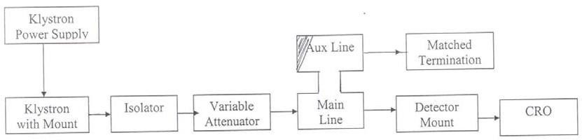

Coupling Factor (V14) measurement

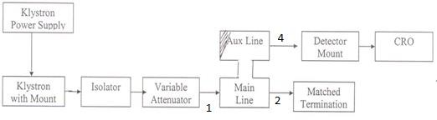

## DESIGN:

Design of a five-hole 30 dB directional coupler with Chebyshev distribution for wavelength ratio of 2 at the band edges.

n=5 r =2

The reverse voltage

CR = 2[C1cos(5-1) + C2 cos(5-3) ] + C3

**=** 2[C1cos4 + C2 cos2] + C3

**=** 2[C1 (8cos4-8 cos2+1] + C2 (2cos2-1)] + C3 At the band edge f=f1 and =1 = /1+r =/3

A change of variable according to cos  = xcos1 gives cos  = xcos (/3) = x/2 CR = 2[C1(x4/2-2x2+1) + C2 (x2/2-1)] + C3

= C1 x4+ (C2-4 C1) x2 + (C3+2C1-2C2)

= Cm T5-1(x)

= Cm(8x4-8x2+1)

Equating the coefficients

C1 = 8C, C2 = 4 C1-8 Cm, C3 + 2C1-2C2 = Cm, C3 = 33Cm

### Now coupling

C = 2**(**C1 + C2) + C3=30dB

= 10**-30/20**

= 0.0316

(or)

2(8+24) Cm+33 Cm=0.0316

97 Cm= 0.0316

Cm = 3.264X10-4

Coupling values of the holes are C1 =8 Cm = 26.08x10-4

C2 =24Cm =78.24x10-4

C3 =33 Cm=107.58x10-4

Directivity D = - C1+20log (1/ Cm) D=39.7dB

**TABULATION**

## DIRECTIVITY MEASUREMENT

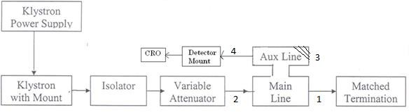

**POST LAB QUESTIONS:**

1. Explain how back power is zero in a directional coupler with neat diagram.
2. What is multi hole directional coupler?
3. What are the factors used to determine the parameters of directional coupler?
4. List the applications of directional coupler.
5. A directional coupler having the directivity of 35dB, forward voltage V14= 10mV. Calculate its input voltage and V24
6. A four-port directional coupler has 4:1 power splitting ratio and has dissipation loss of 3dB. The coupler directivity is 40 dB. What fraction of input power P1 will go to ports P2 and P3?

## RESULT:

Thus, the power distribution in various ports of a directional coupler was studied and the following parameters are calculated.

Coupling factor Directivity Insertion loss

## EXP NO: 3 STUDY OF POWER DISTRIBUTION IN E PLANE, H PLANE AND MAGIC TEE

* + 1. **OBJECTIVE**

To determine isolations and coupling coefficients for E, H plane Tee and Magic Tee junctions.

## HARDWARE REQUIRED

Klystron power supply, Klystron with mount, isolator, variable attenuator, Magic Tee, Matched termination, detector mount, CRO

## INTRODUCTION

### H Plane Tee:

Figure 1 shows the sketch of H plane tee. It is clear from the sketch that an auxiliary waveguide arm is fastened perpendicular to the narrow wall of a main guide, thus it is a three port device in which axis of the auxiliary or side arm is parallel to the planes of the magnetic field of the main guide and the coupling from the main guide to the branch guide is by means of magnetic fields. Therefore, it is also known as H plane tee. The perpendicular arm is generally taken as input and other two arms are in shunt to the input and hence it is also called as shunt tee. Because of symmetry of the tee; equivalent circuit of H plane, when power enters the auxiliary arm, and the two main arms 1 and 2 are terminated in identical loads, the power supplied to each load is equal and in phase with one another. Thus H plane tee is an `adder’.

### E Plane Tee:

Figure 2 shows the sketch of E plane tee. It is clear from the sketch of the E plane tee that an auxiliary waveguide arm is fastened to the broader wall of the main guide. Thus, it is also a three-port device in which the auxiliary arm axis in parallel to the plane of the electric fields of the main guide, and the coupling from the main guide to the auxiliary guide is by means of electric fields. Therefore, it is also known as E plane tee. It is clear that it causes load connected to its branches to appear in series. So, it is often referred to as a series tee. E plane tee divides the power equally and 180 out of phase. Thus E plane Tee is a subtract or / differentiator.

### Magic Tee:

An interesting type of T junction is the hybrid tee, commonly known as `magic tee’ which is shown in Figure 3. The device as can be seen from Fig. is a combination of the E arm and H plane tees. Arm 3, the H arm forms an H plane tee and arm 4, the E arm, forms an E plane tee in combination with arms 1 and 2. The central lines of the two tees coincide and define the plane of symmetry, that is, if arms 1 and 2 are of equal length, the part of structure on one side of the symmetry plane shown by shaded area is the mirror image of that on the other. Arms 1 and 2 are sometimes called as the side or collinear arms. The

`magic Tee’ is derived from the manner in which power divides among the various arms. If power is fed into arm 3, the electric field divides equally between arms 1 and 2 and the fields are in phase. Because of symmetry of the T junction, no net electric field parallel to the narrow dimension of the waveguide is excited in arm 4. Thus no power is coupled in port 4. Reciprocity demands no coupling in port 3 if power is fed in 4. Another property that results from the symmetry of the junction is, if power is fed in E or H arm, it is equally divided between arms 1 and 2.

## PRELAB QUESTIONS:

1. What is Tee junction? Give two examples
2. What is the other name for Hybrid ring?
3. Name some wave guide components used to change the direction of the guide through an arbitrary angle
4. What is the S matrix of H plane Tee junction?
5. List some Applications of magic Tee.

## EXPERIMENT

**PROCEDURE:**

### E Plane & H Plane Tee and Magic Tee: Isolation & Coupling Coefficient

* + - * 1. Energize the microwave source and set mode 3.
        2. Note down the input voltage as Vi (mv) (should not alter the setting)
        3. Now connect the magic tee/E-Plane/H-Plane Tee.
        4. Determine the corresponding voltages Vj (mv) for each pair of ports by connecting one port to the source and measuring the output at other port while the remaining ports are connected to matched termination.
        5. Determine the isolation and coupling coefficients for the given Tee using the following formula.

## BLOCK DIARGAM

**Characteristics of E & H Plane Tee**

CRO

Matched Termination

Detector Mount

E/H Tee

Variable attenuator

Isolator

Klystron with Motor

Klystron Power Supply

**(i) TABULATION:**

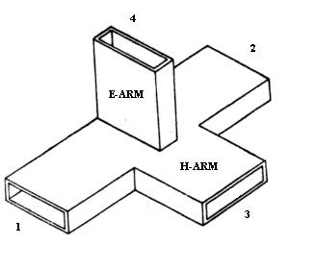**E-Plane Tee H- Plane Tee**

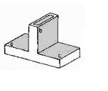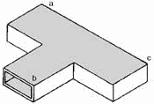

**Characteristics of Magic Tee**

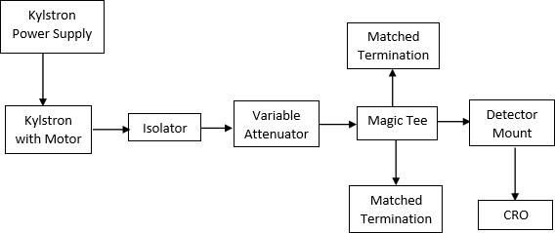

**Magic Tee**

## POST LAB QUESTIONS:

1. Microwave components used to connect branch waveguide to the main waveguide or transmission line are known as
2. What are series and shunt Tee?
3. Justify the name ‘Magic’ in magic tee.
4. Why phase change of 180 degree is observed in series tee in electric field and not in shunt Tee?
5. How does power equally divide between two collinear arms?
6. If a microwave signal with 1V 0 phase is fed at port3 of E-plane Tee, then what will be the output at port1 and port2?
7. If 1V microwave signal is fed to both port1 and port2 of H-plane Tee then, what is the output at port3?
8. If a microwave signal with 1V is fed at port3 of Magic Tee, then what will be the output at port4?

## RESULT:

Thus, the power distribution in various ports of E, H and magic tee was studied.

Isolations and coupling factor are determined.

## EXP NO:4 IMPEDENCE MEASUREMENT BY SLOTTED LINE METHOD

**OBJECTIVE**

To measure the impedance of an unknown load using slotted Line.

## HARDWARE REQUIRED

Klystron Power supply, Klystron with mount, Isolator, Frequency meter, Variable attenuator, Slotted section, Movable Short, CRO.

## INTRODUCTION

The simplest method for measurement of impedance at microwave frequencies is as follows. The unknown impedance is connected at the end of a slotted coaxial line. Microwave power is fed from the other end of coaxial line. Unknown impedance reflects a part of this power. This reflection coefficient is measured by probing the standing wave fields in the slotted line by a suitable arrangement. The reflection coefficient is given by



ZL - Load impedance at any point

Z0 - Characteristics impedance of waveguide at operating frequency

Thus if  is measured & Z0 is known, ZL can be found. In general ZL is complex, both magnitude and phase of  is needed. The magnitude of  may be found from VSWR measurement.



The phase of  may be found by measuring the distance of first voltage minima from the load. Thus the measurement of impedance involves the measurements of VSWR and the distance of the voltage minima from the load. These measurements may be carried out by using a slotted line and probe arrangement.

## PRELAB QUESTIONS

1. What are the types of methods used in microwave frequencies to measure impedance?
2. Relation-ship between S & P.
3. Define VSWR.
4. Microwave impedance measurement at different frequencies can be achieved with the help of
5. A loaded cavity has a lower value of Q factor than an unloaded cavity. Comment.

**TABULATION**

## EXPERIMENT

**EXPERIMENT PROCEDURE**

* + - 1. Assemble the components as per the circuit diagram
      2. After making initial adjustments, mode 3 is set up for operations
      3. The frequency of the excited wave is found by adjusting the frequency meter for a dip in the output meter. Thereafter detune the frequency meter slightly
      4. The VSWR is found for the given load (horn), by measuring Vmax and Vmin.
      5. Probe carriage is moved to one reference point. With load-end terminated with the given load, the first minima (X) is noted from the reference point.
      6. The given load is replaced with short-circuit, the first minima (Y) or d1 is noted down from the same reference point. Moving the carriage further determine the successive minima (d2). i.e., With load - end short circuited, two successive minimas (d1 and d2) are found out by moving the probe carriage along the slotted waveguide line.
      7. Find the shift (X-Y). Depending on whether the carriage is moved towards the load or source, it will be positive or negative.
      8. The impedance of the unknown load is found using smith chart and verified using formula.

### Calculation of Impedance using Smith Chart

1. Determine VSWR of the given load from the measurement
2. Draw a VSWR Circle
3. Calculate the shift l in terms of wavelength.
4. Locate the shift point from (0,0) moving clockwise (if l is negative) or anticlockwise(if l is positive) on the circumference.
5. Join the point to the centre of smith chart.
6. The intersection of VSWR circle and the line gives the normalized load impedence (ZL)

### Theoretical Calculations:

Load impedance **(ZL)** is calculated from the product of normalized impedance and characteristic impedance of slotted line.

## FORMULA

**FORMULA:**

**Characteristics Impedance Z0**

Z0   -(fc/f0))2

*ZL* =

1- *j* (*VSWR*) tan l

zo *VSWR* -*j* tan l



l = (X-Y) / g

Fc  Cutoff frequency

Fc = c/c

c  Cut off wavelength

c = 2a

A  inner broad dimension of waveguide

g = 2(d1  d2)

VSWR = Vmax/Vmin

**BLOCK DIAGRAM IMPEDANCE MEASUREMENT**



**CRO**

Tunable probe

Movable

short/ Load

Slotted Section with Probe Carriage

Variable Attenuator

Frequency Meter

Klystron with Mount

Isolator

Klystron Power Supply

## POSTLAB QUESTIONS

1. How will you measure the impedance of the unknown load in the microwave setup bench?
2. What are the application of smith chart?
3. What is the input impedance of the shorted line and open line?
4. 



Calculate the following parameters

* 1. 0 g, VSWR and ZL.
  2. Identify ZL is capacitive or reactive.

## RESULT

The impedance of an unknown load was calculated the value was found out to be From smith chart:

From theoretical calculations:

# Ex: NO:5(A)

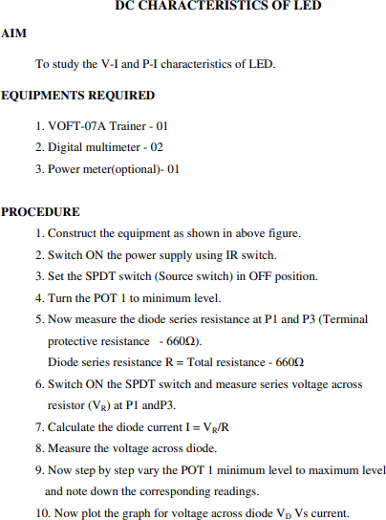

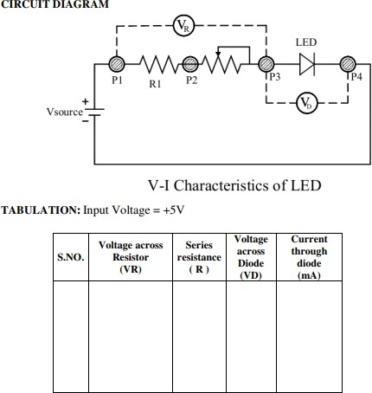

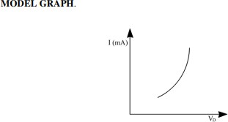

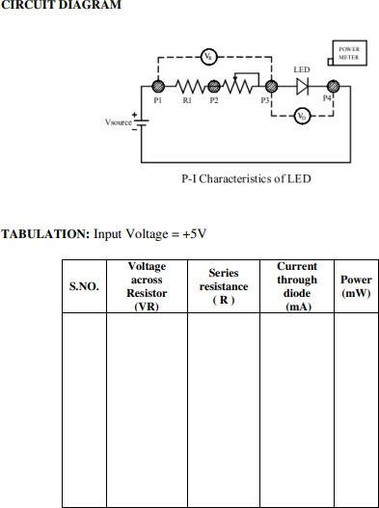

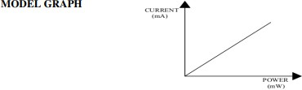

**TABULATION**

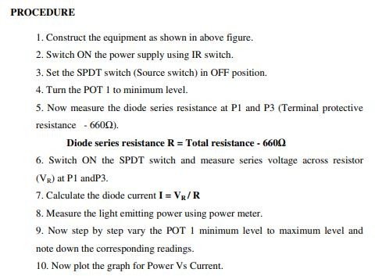



**5(B) DC CHARACTERISTICS OF LASER DIODE**

**OBJECTIVE:**

To study the DC characteristics of LASER diode.

**HARDWARE REQUIRED**

1. OFT power supply (OFT power supply can be used for LD module)

2. A digital multi-meter

3. Benchmark LD unit

4. Benchmark LD drive module with its accessories

5. Benchmark Fiber Optic Power meter with ST adaptor

6. Mounting Posts

**THEORY**

A laser diode is a laser where the active medium is a semiconductor similar to that found in a light-emitting diode. The most common and practical type of laser diode is formed from a p-n junction and powered by injected electric current. These devices are sometimes referred to as injection laser diodes to distinguish them from (optically) pumped laser diodes, which are more easily manufactured in the laboratory. A laser diode, like many other semiconductor devices, is formed by doping a very thin layer on the surface of a crystal wafer. The crystal is doped to produce an ntype region and a p-type region, one above the other, resulting in a p-n junction, or diode. When an electron and a hole are present in the same region, they may recombine or "annihilate" with the result being spontaneous emission — i.e., the electron may reoccupy the energy state of the hole, emitting a photon with energy equal to the difference between the electron and hole states involved. (In a conventional semiconductor junction diode, the energy released from the recombination of electrons and holes is carried away as phonons, i.e., lattice vibrations, rather than as photons.) Spontaneous emission gives the laser diode below lasing threshold similar properties to an LED. Spontaneous emission is necessary to initiate laser oscillation, but it is one among several sources of inefficiency once the laser is oscillating.

**PRECAUTION**

Laser radiation. Avoid direct eye or skin exposure to laser beam while setting up the system or conducting experiments. Always view only the reflected rays while setting up the system or while conducting experiments.

**PROCEDURE**

1. Setup the LD module as shown in the figure.

2. Keep the potentiometer at the minimum position. Turn ON the power to the module.

3. Now without changing any voltage or the multi-turn post position, measure the optical power output P of the LD.

4. Increase the current through LD by turning the multi-turn pot clockwise direction slightly towards the maximum till you get a convenient reading V1 and repeat the steps 2 to 5 and tabulate them as shown below.

5. Repeat step 4 till multi-run pot reaches its maximum position and plot the graph for 

6. The threshold current of the LD can be found out from the P-I characteristics graph. Note down the current from the P-I graph at which there is a sharp rise in the optical output power. This is the threshold current of the LD.

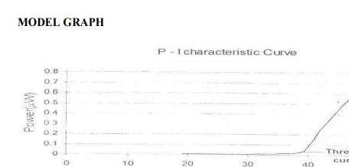

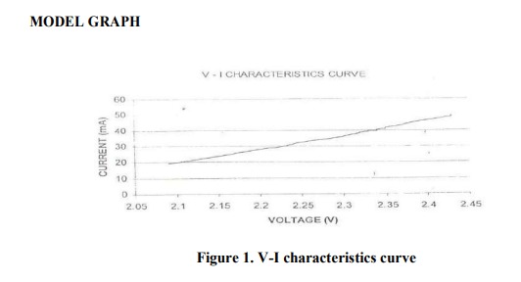

**TABULATION**

**RESULT :**

The DC characteristics of a Laser Diode were studied and plotted

## EXP. NO: 6(A) D.C. CHARACTERISTICS OF PIN PHOTODIODE

**OBJECTIVE**

To study the characteristics of the given Photo Detector at zero-bias, Forward Bias and Reverse Bias conditions.

## HARDWARE NEEDED

OFT power supply, A digital multi-meter, PD Module, Benchmark Fiber Optic Power Source, Benchmark Fiber Optic Power Meter, 1m Patch cord (PSTO-PC-1), 1 M,10K resistors, 10K, 6.8K, 4.7K, 3.3K, 3.9K & 2.2K resistors (for reverse bias),Ambient light arrester.

## INTRODUCTION

A **photodiode** is a type of photodetector capable of converting light into either current or voltage, depending upon the mode of operation.

Photodiodes are similar to regular semiconductor diodes except that they may be either exposed (to detect vacuum UV or X-rays) or packaged with a window or optical fiber connection to allow light to reach the sensitive part of the device. Many diodes designed for use specifically as a photodiode will also use a PIN junction rather than the typical PN junction.

A photodiode is a PN junction or PIN structure. When a photon of sufficient energy strikes the diode, it excites an electron, thereby creating a mobile electron and a positively charged electron hole. If the absorption occurs in the junction's depletion region, or one diffusion length away from it, these carriers are swept from the junction by the built-in field of the depletion region. Thus holes move toward the anode, and electrons toward the cathode, and a photocurrent is produced.

### Photovoltaic mode

When used in zero bias or photovoltaic mode, the flow of photocurrent out of the device is restricted and a voltage builds up. The diode becomes forward biased and "dark current" begins to flow across the junction in the direction opposite to the photocurrent. This mode is responsible for the photovoltaic effect, which is the basis for solar cells—in fact, a solar cell is just a large area photodiode.

### Photoconductive mode

In this mode the diode is often reverse biased, dramatically reducing the response time at the expense of increased noise. This increases the width of the depletion layer, which decreases the junction's capacitance resulting in faster response times. The reverse bias induces only a small amount of current (known as saturation or back current) along its direction while the photocurrent remains virtually the same. The photocurrent is linearly proportional to the illuminance.

### Critical performance parameters of a photodiode include:

**Responsivity**

The ratio of generated photocurrent to incident light power, typically expressed in A/W when used in photoconductive mode. The responsivity may also be expressed as a *quantum efficiency*, or the ratio of the number of photo generated carriers to incident photons and thus a unitless quantity.

### Dark Current

The current through the photodiode in the absence of light, when it is operated in photoconductive mode. The dark current includes photocurrent generated by background radiation and the saturation current of the semiconductor junction. Dark current must be accounted for by calibration if a photodiode is used to make an accurate optical power measurement, and it is also a source of noise when a photodiode is used in an optical communication system.

### Noise-Equivalent Power

(NEP) The minimum input optical power to generate photocurrent, equal to the rms noise current in a 1 hertz bandwidth. The related characteristic *detectivity* (D) is the inverse of NEP, 1/NEP; The NEP is roughly the minimum detectable input power of a photodiode. When a photodiode is used in an optical communication system, these parameters contribute to the *sensitivity* of the optical receiver, which is the minimum input power required for the receiver to achieve a specified *bit error ratio*

## PRELAB QUESTIONS

1. What is photo detector?
2. List some of the operating performance and requirements of optical detectors.
3. What is impact ionization?
4. Draw the simple model of a photo detector receiver.
5. What is the figure of merit of a photodetector?

## PRECAUTION

Before switching between the bias modes, it is recommended to switch OFF the PD module and the power supply. This ensures that the voltages are not reversed or applied quickly to the PD. Failure to do so may result in permanent damage to PD and its power supply.

## EXPERIMENT

**PROCEDURE**

### Photo-detector at Zero bias

Connect the OFT power supply to the module using the DIN-DIN cable provided with the power supply. Set the bias switch to the zero bias configuration (Bias switch moved to the top most position). Turn the bias voltage varying pot in the PD module to its minimum position and switch ON the module. The zero bias LED lights up.

The module at the zero bias configuration is shown in Fig.1. The photodiode is given no bias voltage. The current induced by the photo-detector due to the incident optical power on to it, flows through the load resistor.

### Photo detector setup

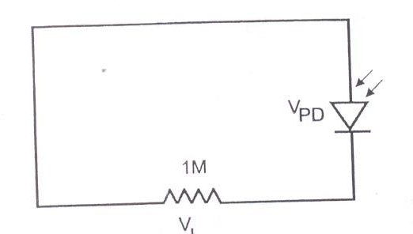

**Figure 1 : PD with zero bias configuration**

1. Put 1 M ohm resistor across VL.
2. Connect the ST connector end of the patch cord supplied with the module to the power source.
3. Set the Power source in CW mode and to give maximum output power (refer Benchmark power source manual on how to adjust the power). Connect 1m patch cord between source and meter (use bare fiber adaptor – plastic at the power meter end) and measure this optical power P and adjust the power in source such that it reads -18dBm approx. Note down this power.
4. Slightly unscrew the black colored cap of the PD to loosen it without removing it from the connector assembly. Remove the patch cord from the power meter and gently push the fiber into the black cap until it is held in place. Now tighten the black cap by screwing it back. The fiber will now be held firmly in place. Now measure the voltage across V1.
5. Vary the optical power P from -18dBm approx in steps of 5dBm.To reduce the power more than what the power source can attenuate remove the ST connector of the patch cord slightly that is connected to the power source. This gives the natural attenuation. Ensure that this loose connector is not disturbed while connecting and removing the patch cord between meter and PD. May be you can stick the cable on to the table with a sticking tape near the source. Tabulate the readings as follows:

## TABULATION

## MODEL GRAPH

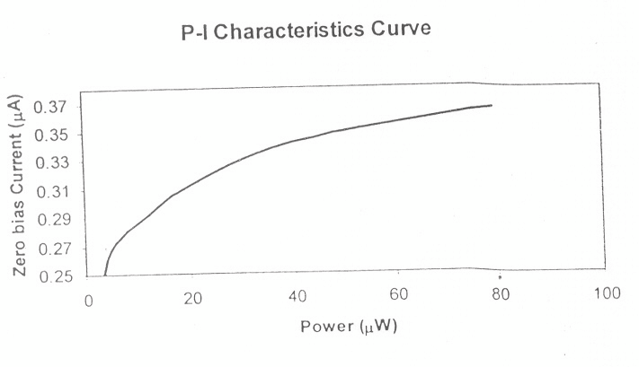

### Figure 2 Power Vs Current graph

**Photo-detector at Forward bias**

Connect the OFT power supply to the module using the DIN-DIN cable provided with the power supply. Set the bias switch to the forward bias configuration (Bias switch moved tot eh middle position). Turn the bias voltage varying pot in the PD module to its minimum position and switch ON the module. The forward bias LED lights up.

The module at the forward bias configuration switches the photodiode to a basic configuration as shown in Fig.3. The photodiode is given forward bias voltage.

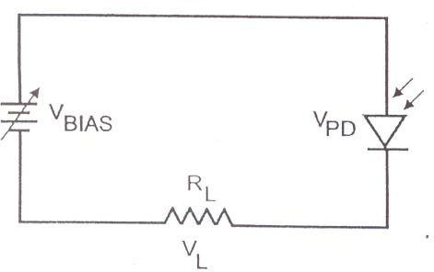

### Figure 3: PD with forward bias configuration

1. Put 10K resistor across VL.
2. Adjust the potentiometer and fix the bias voltage at 10V
3. Connect the ST connector end of the patch cord supplied with the module to the power source.
4. Set the Power source in CW mode and to give maximum output power (refer Benchmark power source manual on how to adjust the power). Connect 1m patch cord between source and meter (use bare fiber adaptor – plastic at the power meter end) and measure this optical power P and adjust the power in source such that it reads – 18dBm approx. Note down this power.
5. Slightly unscrew the black colored cap of the PD to loosen it, without removing it from the connector assembly. Remove the patch cord from the power meter and gently push the fiber into the black cap until it is held in place. Now tighten the black cap by screwing it back. The fiber will now be held firmly in place. Now measure the voltage VL.
6. Vary the optical power P from – 18 dBm to -40 dBm approx in steps of 5dBm. To reduce the power more than what the power source can attenuate, remove the ST connector of the patch cord slightly that is connected to the power source. This gives the natural attenuation. Ensure that this loose connector is not disturbed while connecting and removing the patch cord between meter and PD. May be you can stick the cable on to the table with a sticking tape near the source. Tabulate the readings.
7. Plot the graph P vs If. The sample graph is shown in Fig.4

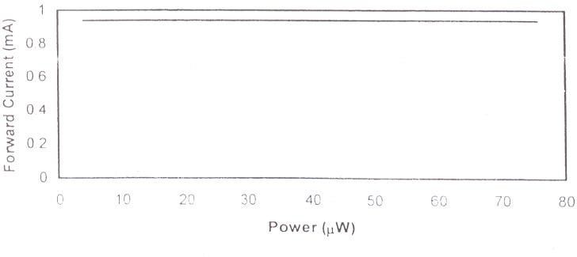

### Figure 4 Power Vs Current graph

1. Now fix the power launched as – 20 dBm.
2. Vary the bias voltage from 2V to 10V by adjusting the potentiometer and measure VL.
3. Tabulate the values and plot the graph VBIAS Vs IL. The sample graph is shown in Fig.5

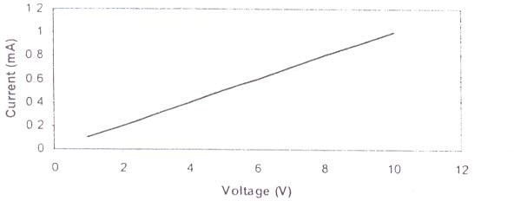

### Fig. 5 Voltage Vs. Current graph Photo-detector at Reverse Bias

Connect the OFT power supply to the module using the DIN-DIN cable provided with the power supply. Set the bias switch to the reverse bias configuration (Bias switch moved to the bottom most position). Turn the bias voltage varying pot in the PD module to its minimum position and switch ON the module. The reverse bias LED lights up.

The module at the reverse bias configuration switches the photodiode to a basic configuration as shown in Fig.6. The photodiode is given reverse bias voltage. The current induced by the photodiode due to the incident optical power on to it, flows through the load resistor.

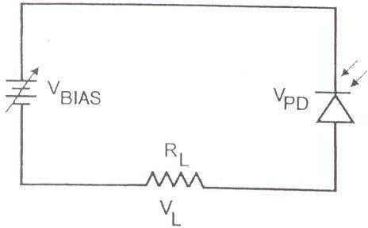

### Figure 6: PD with reverse bias configuration

1. Put 10K resistor across VL.
2. Adjust the potentiometer and fix the bias voltage at 10V.
3. Connect the ST connector end of the patch cord supplied with the module to the power source.
4. Set the Power source in CW mode and to give maximum output power (refer Benchmark power source manual on how to adjust the power). Connect 1m patch cord between source and meter (use bare fiber adaptor plastic at the power meter end) and measure this optical power P and adjust the power in source such that it reads –18dBm approx. Note down this power.
5. Slightly unscrew the black colored cap of the PD to loosen it, without removing it from the connector assembly. Remove the patch cord from the power meter and gently push the fiber into the black cap until it is held in place. Now tighten the black cap by screwing it back. The fiber will now be held firmly in place. Now measure the voltage VL.
6. Vary the optical power P from – 18dBm to -40dBm approx in steps of 5dBm. To reduce the power more than what the power source can attenuate, remove the ST connector of the patch cord slightly that is connected to the power source. This gives the natural attenuation. Ensure that this loose connector is not disturbed while connecting and removing the patch cord between meter and PD. maybe you can stick the cable on to the table with a sticking tape near the source. Tabulate the readings as follows:
7. Plot the graph P vs IR. The sample graph is shown in Figure 7.

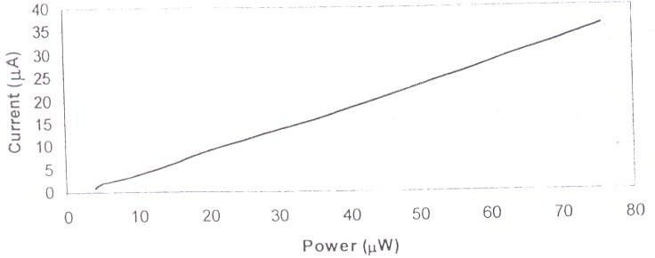

### Figure 7: Power Vs Current graph

1. Now fix the power launched as – 20 dBm.
2. Vary the bias voltage from 2V to 10V by adjusting the potentiometer and measure VL. Tabulate the values.
3. For each value of the bias voltage and current calculate the value of the responsivity from the formula. Are all the R values approximately same? What do you infer from this?

R = VL/(RL* PS) A/W

where PS is the power in W.

1. From the average value of R calculate the value of the quantum efficiency from the formula

ƞ = Rλ h  / e x 100% where h = 6.624 x 10-34 JS, is the Planck’s constant

= C/λ = 3 x 108 / 850 x 10-9 Hz , is frequency of the incident photons e = 1.6 x 10-19 Coulombs, is the electric charge

Repeat the above steps for various values of RL 6.8K, 4.7K, 3.9K & 2.2K.

### Leakage Characteristics of Photo-detector

One among the important characteristics of a photodiode is its leakage characteristics when it is reverse biased. Since the leakage current through the photo-detector is normally very less, increased bias voltage and higher value of RL is used in the module at the reverse bias configuration. The basic configuration of the PD module in leakage characteristics is shown in Fig.8.

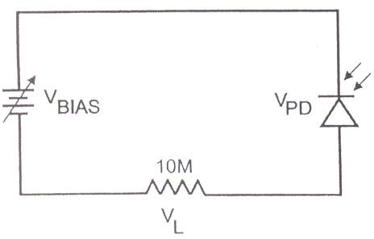

### Figure 8: PD with leakage characteristics

**Caution**

Before switching between the bias modes, it is recommended to switch OFF the PD module and the power supply. This ensures that the voltages are not reversed or applied quickly to the PD. Failure to do so may result in permanent damage to PD and its power supply.

### Procedure:

Connect the OFT power supply to the module using the DIN-DIN cable provided with the power supply. Set the bias switch to the reverse bias configuration (Bias switch moved to the bottom most position). Turn the bias voltage varying pot in the PD module to its minimum position and switch ON the module. The reverse bias LED lights up.

1. Put 10 M resistors across VL.
2. Adjust the potentiometer and fix the bias voltage as 10V.
3. Screw in the free end of the ambient light arrester unit supplied with the module to the PD. This is done to avoid ambient light falling on the Photodiode.
4. Measure the voltage VL.
5. Repeat the above procedure for various values of bias voltage and tabulate.
6. Plot the graph using Vbias and Idark and the sample graph is shown in fig.9 Idark = VL / RL|| Rm A

where Rm is the multi-meter input impedance which is normally 10MΩ.

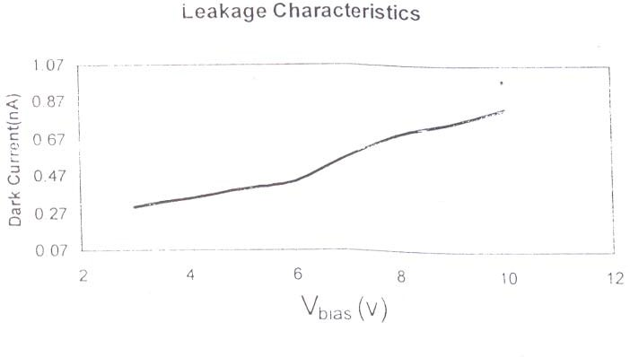

**Figure 9. Voltage Vs Dark Current graph**

## POSTLAB QUESTIONS

1. Photo detector is a square law device. Justify.
2. What is quantum efficiency?
3. What is dark current?
4. Define noise equivalent power.
5. What is the cutoff wavelength of a photodetector? Give the expression.
6. An InGaAs PIN photodiode has the following parameters at a wavelength of 1300nm: ID=4nA, ƞ=0.90, RL=1000Ω, and the surface leakage current is negligible. The incident optical power is 300Nw (-35dBm), and the receiver bandwidth is 20MHz. Find the various noise terms of the receiver.

## RESULT

Thus the V-I characteristics of PIN photodiode has been studied and following parameters are determined.

Rλ = η =

## EXP. NO:6(B) D.C. CHARACTERISTICS OF AVALANCHE PHOTODIODE

**OBJECTIVE**

To study the characteristics of the given avalanche photodiode at zero-bias and Reverse Bias conditions.

## HARDWARE NEEDED

1. APD power supply
2. A digital multi-meter
3. APD Module
4. Benchmark Fiber Optic Power Source
5. Benchmark Fiber Optic Power Meter
6. ST-ST multimode patch cord (ST-PC-1)
7. Ambient light arrester

## INTRODUCTION

Avalanche Photodiode, popularly called as APD, is a photo-detector that allows internal multiplication to take place and hence amplified current flows through it when its reverse bias is increased beyond certain point. APD allows normal PIN photodiode characteristics without any gain when operated under low voltage conditions.

A high gain, close to a factor of 100, is achievable when the reverse bias approaches close to its breakdown voltage. It is advisable not to cross the breakdown point as it will permanently damage the device.

APDs are high speed devices and also very highly sensitive. With its internal gain mechanism, these are useful for measuring very low value of optical power. Because of these characteristics, these are primarily used in very long-distance communications, OTDRs, WANs, optical measurements, etc,

### Principle of Avalanche Multiplication

When light enters the photodiode, electron-hole pairs will be generated if the applied light energy is greater than the band gap energy of the photodiode when it is reverse biased. The movement of electron-hole pairs generates electric current in a photodiode. If the reverse bias voltage is increased, ionization of the carriers takes place thereby more number of electron-hole pairs will be generated. These newly created electron-hole pairs in turn undergo ionization and hence produce additional electron hole pairs and this continues like a chain reaction. This process of electron hole pair generation is referred as avalanche multiplication and this is the principle involved in APD. This avalanche multiplication in APD is a function of reverse bias voltage.

Light energy and the wavelength have a relationship as shown below λ = 1240nm / E

E- band gap energy of the Si photodetector.

The band gap energy for Si is 1.12 eV at room temperature and hence Si photodetector are sensitive to light wavelength shorter than 1100nm.

## PRELAB QUESTIONS

1. What is avalanche multiplication?
2. Draw RAPD (Reach through Avalanche Photodiode) structure and the electric fields in depletion and avalanche multiplication regions.
3. Compare the performance of Si-PIN and Si-APDs in terms of wavelength range, dark current and bias voltage.
4. Define avalanche multiplication noise.
5. List some practical applications of APD

## PRECAUTION

Before switching between the bias modes, it is recommended to switch OFF the APD module and the power supply. This ensures that the voltages are not reversed or applied quickly to the APD. Failure to do so may result in permanent damage to A PD and its power supply.

## EXPERIMENT

**PROCEDURE**

### APD at Zero bias

Connect the APD power supply properly to the module using the DIN-DIN cable provided with the power supply. Set the bias switch to the zero bias configuration. Turn the bias voltage varying pot in the APD module to its minimum position and switch ON the module. The zero bias LED lights up. The module at zero bias is shown in figure.1.

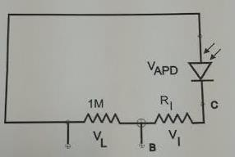

### Figure 1 : APD with zero bias configuration

The photodiode is given no bias voltage. The current induced by the photo detector due to the incident optical power on to it, flows through the load resistor.

1. Put 1 M ohm resistor across VL.
2. Set the Power source in CW mode and to give maximum output power (refer Benchmark power source manual on how to adjust the power). Connect 1m ST-ST patch cord between source and meter (use bare fiber adaptor – plastic at the power meter end) and measure this optical power P and adjust the power in source such that it reads -18dBm approx. Note down this power and connect this patch cord between APD and power source. Measure the voltage across VL.
3. Vary the optical power P from -18dBm to -40dBm approx in steps of 5dBm. To reduce the power more than what the power source can attenuate remove the ST connector of the patch cord slightly that is connected to the power source. This gives the natural attenuation. Ensure that this loose connector is not disturbed while connecting and removing the patch cord between meter and APD.

## TABULATION

## MODEL GRAPH

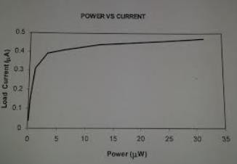

### Figure 2 Power Vs Current graph

**APD at Reverse Bias**

Connect the APD power supply properly to the module using the DIN-DIN cable provided with the power supply. Set the bias switch to the reverse bias configuration. Turn the bias voltage varying pot in the APD module to its minimum position and switch ON the module. The reverse bias LED lights up.

The module at the reverse bias configuration switches the photodiode to a basic configuration as shown in Fig.3. This mode of operation is also called as photoconductive operation. The photodiode is given reverse bias voltage. The current induced by the photodiode due to the incident optical power on to it, flows through the load resistor.

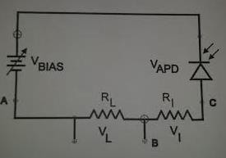

### Figure 3: APD with reverse bias configuration

1. Put 1K resistor across VL.
2. Set the Power source in CW mode and to give maximum output power (refer Benchmark power source manual on how to adjust the power). Connect 1m ST-ST patch cord between source and meter (use bare fiber adaptor plastic at the power meter end) and measure this optical power P and adjust the power in source such that it reads –18dBm approx. Note down this power and connect this patch cord between APD and power source. Set the APD bias to 10V by adjusting the bias pot. Measure the voltage across VL.
3. Vary the bias voltage from 10V to 140V or to the maximum voltage that is possible in steps of 20V approx and note down the voltage across VL and tabulate. Fix power P= -18dBm.
4. Plot the graph VBias Vs IR. The sample graph for a load resistor of 100K and power of - 15dBm is shown in Figure 4.

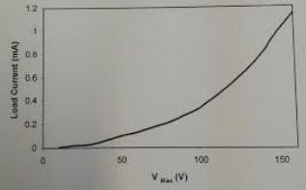

**Figure 4: Bias Voltage Vs load Current graph**

1. From the table, for each value of the bias voltage and current, calculate the value of responsivity R

R = VL/(RL* PS) A/W

where PS is the power in W.

1. From the value of R calculate the value of the quantum efficiency from the formula

ƞ = Rλ h  / e x 100% where h = 6.624 x 10-34 JS, is the Planck’s constant

= C/λ = 3 x 108 / 850 x 10-9 Hz , is frequency of the incident photons IR = VL /1 x 103

e = 1.6 x 10-19 Coulombs, is the electric charge.

### Leakage Characteristic of Avalanche Photo-detector

One among the important characteristic of a photodiode is its leakage characteristic when it is reverse biased. Since the leakage current through the photo detector is normally very less, increases bias voltage and higher value of RL is used in the module at the reverse bias configuration. The basic configuration of the PD module in leakage characteristic is shown in Fig.5.

P



VBIAS

VA

10

### Caution:

V

**Figure 5: APD with leakage characteristics**

Before switching between the bias modes, it is recommended to switch OFF the PD module and the power supply. This ensure that the voltages are not reversed or applied quickly to the PD. Failure to do so may result in permanent damage to PD and its power supply.

### Procedure:

Connect the OFT power supply to the module using the DIN-DIN cable provided with the power supply. Set the bias switch to the reverse bias configuration (Bias switch moved to the bottom most position). Turn the bias voltage varying pot the PD Module to its minimum position and switch ON the module. The reverse bias LED light up.

1. Put 10 M resistors across VL.
2. Adjust the potentiometer and fix the bias voltage as 10V.
3. Screw in the free end of the ambient light arrester unit supplied with the module to the PD. This is done to avoid ambient light falling on the Photodiode.
4. Measure the voltage VL
5. Repeat the above procedure for various values of bias voltage and tabulate.
6. Plot the graph using Vbias and Idark and the sample graph is shown in Fig.5

𝐼𝑑𝑎𝑟𝑘 = (𝑉𝐿/ 𝑅𝐿‖𝑅𝑚) 𝐴

Where Rm is the multi-meter input impedance which is normally 10MΩ.

* + 1. **POSTLAB QUESTIONS**

1. Mention the major advantage of avalanche photodiode over PIN photodiode.
2. Write the expression for gain-bandwidth product of APD.
3. What is dark current?
4. What are the practical challenges that a designer undergoes while using APD?
5. Statement: Gain-bandwidth product is an important characteristic of an APD. Justify this statement. Why don’t we use this characteristic for p-i-n photodiode?

## RESULT

Thus, the V-I characteristics of Avalanche photodiode has been studied and following parameters are determined.

Rλ = η = M =

## EXP NO: 7(A) MEASUREMENT OF NUMERICAL APERTURE OF OPTICAL FIBER

**OBJECTIVE:**

To measure the numerical aperture of a given optical fiber at 650 nm

## HARDWARE REQUIRED:

Optical fiber, Numerical Aperture Measurement Kit

## INTRODUCTION:

Numerical aperture (NA) of a fiber is a measure of the acceptance angle of light in the fiber. Light which is launched at angles greater than this maximum acceptable angle does not get coupled to propagating modes in the fiber and therefore does not reach the receiver at the other end of the fiber. The Numerical aperture is useful in the computation of optical power coupled from an optical source to the fiber, from the fiber to a photo detector and between two fibers.

## DIAGRAM

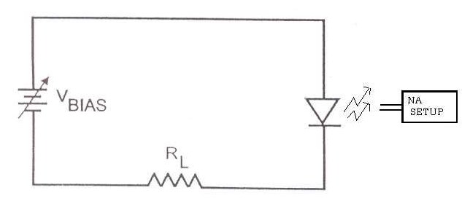

**Figure 1: Numerical aperture setup**

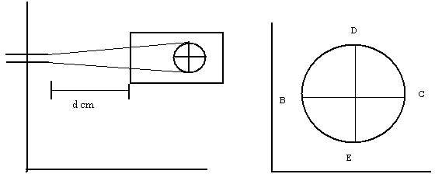

**Figure 2: Numerical aperture**

## PRELAB QUESTIONS

1. Define angle of acceptance.
2. If the angle of acceptance is 30 degree, what is the value of numerical aperture?
3. What is the formula for numerical aperture?
4. What is lens coupling and butt coupling
5. How to relate Ss law with Numerical Aperture.
6. Why light can travel faster in water compared to glass?
7. How fast is the light traveling inside the water?

## TABULATION:

## PROCEDURE:

1. Insert one end of the fiber into the numerical aperture measurement kit as shown in the figure. Adjust the fiber such that its tip is 10 mm from the screen
2. Gently tighten the screw to hold the fiber firmly in the place.
3. Connect the other end of the fiber to the LED Source through a connector. The fiber will project a circular patch of red light onto the screen. Let **d** be the distance between the fiber tip and the screen. Now measure the diameter of the circular patch of red light in two perpendicular directions (BC and DE in figure). The mean radius of the circular patch is given by

## *X*= (DE + BC)/4

1. Carefully measure the distance *d* between the tip of the fiber and the illuminated screen (OA) as shown in figure. The Numerical aperture of the fiber is given by

### NA = Sin = *X*/(*d*2 + *X*2)1/2

1. Repeat steps 1 to 4 for different values of *d*, compute the average value of Numerical aperture.

## POST LAB QUESTIONS

1. Why do single mode fiber have larger bandwidth as compared to that of multimode fiber?
2. What is pulse dispersion?
3. Light travels from denser medium glass into rarer medium air. What is the critical angle at the interface?
4. Can optical fiber conduct electricity? Why?
5. At what wavelength does silica fiber show minimum attenuation?
6. Give the relation between bandwidth and Numerical aperture (NA).
7. A light ray incident on air water interfaces and refracted at an angle of 40º in the water. Calculate the angle of incidence.

9. A multi-mode optical fiber index has n1 = 1.5 and n2 = 1.4142. Find the maximum value of A for which the incident light from air will be guided in the optical fiber.

## RESULT

Thus, the numerical aperture of a fiber optic cable is determined**.**

## EXP NO: 7 (B) MEASUREMENT OF PROPAGATION LOSS IN OPTICAL FIBER

**OBJECTIVE:**

To measure the propagation loss in an optical fiber.

## HARDWARE REQUIREMENT:

Kit (Fiber link-D), 1 m, 3 m Fiber Cable Link Patch cords Power supply

## INTRODUCTION:

Optical fibers are available in different variety of materials. These materials are usually selected by taking into account their absorption characteristics of different wavelengths of light. Losses a re introduced in fiber due to various reasons. As l ight propagates from one end of fiber to another end, part of it is absorbed in the material exhibiting absorption loss. Also, part of the light is reflected back or in some other direction from the impurity particles present in the material contributing to the loss of the signal at the other end of the fiber. It is known as Propagation loss.

## PRELAB QUESTIONS

1. What are the different types of dispersion?
2. What is group velocity dispersion?
3. What is the difference between attenuation and dispersion?
4. How to increase the signal strength in optical fibers
5. Define attenuation coefficient.
6. What are the reasons for optical signal loss in fiber?

## FORMULA:

Propagation loss: Attenuation in dB/m

 = ln(*Po*1/*Po*2) / (*l*2-*l*1)

where

*Po*1 Output power level (µw) at the end of the fiber of length *l*1 (m)

**P***o*2 Output power level (µw) at the end of the fiber of length *l*2 (m)

## PROCEDURE:

1. Connect the power supply cables with proper polarity to kit. While connecting this, ensure that the power supply is OFF.
2. Connect the AMP O/P as a constant signal to the TX I/P using a patch cord.
3. You will measure the light output using SIGNAL STRENGTH section of the kit. The loss will be more for a longer piece of fiber. In order to measure the loss in the fiber you first need a reference of how much light goes into the fiber from the Light transmitter, you will use the short piece of fiber to measure this reference.
4. Switch on the power supply. Connect the short piece of fiber between the TX and RX of the kit. Adjust the transmitter level until the signal strength reads 6, this will be your reference value. Now connect the long piece of fiber instead of the short piece. What reading do you get? Loss in optical fiber system is usually measured in dB. Loss of fiber itself is measured in dB/meter.
5. Subtract the length of the short fiber from the length of the long fiber to get the difference in the fiber lengths (4m-1m). The extra length of 3 m is what created the extra loss you measured. Then take the signal strength reading you obtained for the loss of the long fiber directly from the power meter.

## MODEL GRAPH

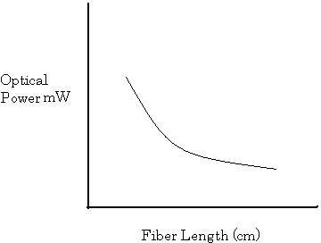

**Figure 1: Optical power vs. Fiber length**

## TABULATION:

* + 1. **POST LAB QUESTIONS**

1. Consider a 10 km optical fiber in which 100 mW power is launched from one end and 50 mW power is received from the other end. Calculate the attenuation in dB/Km.
2. Why optical power decreases with increase in fiber length.
3. A 30 km long optical fiber that has an attenuation of 0.8 dB/km at 1300 nm. Find the optical output power Pout if 200µw of optical power is launched into the fiber.

## RESULT

The propagation loss in fiber optic cable is measured.

## EXP NO: 7(C) MEASUREMENT OF BENDING LOSS IN AN OPTICAL FIBER

**OBJECTIVE**

To measure the bending loss of a fiber optic cable

## HARDWARE REQUIREMENTS:

Kit (Fiber Link-D), 1 m or 3 m fiber cable, Spindles to wound the fiber around it Power

supply.

## INTRODUCTION:

Though the fibers are good at bending, each time the fiber is bent, a little light is lost.

This experiment will measure how much of this light is lost for different sizes of bends.

## PRELAB QUESTIONS

1. What is micro bending and macro bending loss?
2. What is total internal reflection?
3. Define Snel law.
4. Differentiate reflection, refraction and diffraction.

## MODEL GRAPH

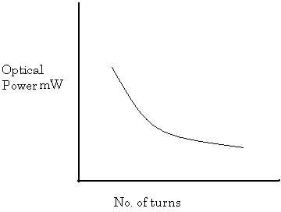

**Figure 1: Optical power vs. No. of turns**

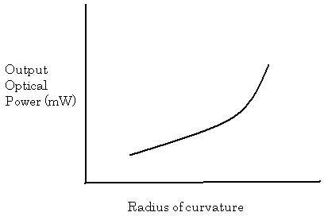

**Figure 2: Optical power vs. Radius of curvature**

## EXPERIMENT

**PROCEDURE:**

1. Connect the power supply cables with proper polarity to kit. While connecting this, ensure that the power supply is OFF.
2. Connect the AMP O/P as a constant signal to the TX I/P using a patch cord. You will measure the light output using SIGNAL STRENGTH section of the kit.
3. Switch on the power supply. Connect the long piece of fiber between the TX and RX of the kit so there are no sharp bends in the fiber between them
4. Adjust the transmitter level until the signal strength reads 6, this will be your reference value. Now take the portion of the fiber and loop it into the spindle and note the signal strength from the power meter, which give the optical signal power in dBW/m.
5. Repeat it for various diameters of the spindle and for various numbers of bend on the spindle and measure the corresponding signal strength from the optical power meter.

## TABULATION:

## POST LAB QUESTION:

1. How light is propagated inside a fiber?
2. Give the merits and demerits of Optical fiber cable.
3. In optical fiber propagation loss increases or decreases with the increase in length of the fiber cable?
4. When the mean optical power launched into an 8 km length of fiber is 120 mW, the mean optical power at the output is 3 mW.

Determine:

* 1. The overall signal attenuation (or loss) in decibels through the fiber assuming there are no connectors or splices.
  2. The signal attenuation per kilometer for the fiber.
  3. The overall signal attenuation for a 10 km optical link using the same fiber with splices (i.e. fiber connections) at 1 km intervals, each giving an attenuation of 1 dB.
  4. The output/input power ratio.

## RESULT

The bending loss in fiber optic cable is determined.

## EXP NO: 8 (A) SETTING UP A FIBRE OPTIC ANALOG LINK

**OBJECTIVE**:

1. To set up an 850 nm fiber optic analog link.
2. To observe the linear relationship between the input and received signal.
3. To measure the bandwidth of link.
4. To observe the effect of gain control received signal.

## HARDWARE REQUIRED:

Optical fiber trainer kit, Two channel 20 MHz oscilloscope, Function generator (1Hz  10MHz)

## INTRODUCTION:

This experiment is designed to familiarize the user with optical fiber trainer kit. An analog fiber optic link is to be set up in this experiment. The preparation of the optical fiber for coupling light in to it and the coupling of the fiber to the LED and detector are quite important. The LED used is an 850nm LED. The fiber is a multimode fiber with a core diameter of 1000µm. The detector is simple PIN detector.

The LED optical power output is directly proportional to the current driving the LED. Similarly, for the PIN diode, the current is proportional to the amount of light falling on the detector. Thus, even though the LED and the PIN diode are non-linear devices, the current in the PIN diode is directly proportional to the driving current of the LED. This makes the optical communication system a linear system.

## PRELAB QUESTIONS:

1. What is point to point link?
2. Define link power buget.
3. What is rise time budget?
4. What is the transmission frequency in optical fiber?
5. In Communication link what is the need for repeater?

## PROCEDURE:

1. Set the switch SW8 to the analog position. Switch the power on. The power on switch is located at the top right-hand corner.
2. Feed a 1 V p-p sinusoidal signal at 1 KHz from a function generator, to the analog in post P11 using the following procedure:
3. Connect a BNC-BNC cable from the function generator to the BNC socket I/03
4. Connect the signal post I/03 to the analog in post P11 using a patch cord.
5. With this, the signal from the function generator is fed through to the analog in signal post P11 from the I/O3 BNC socket.
6. Connect one end of the 1m fiber to the LED source.
7. Observe the light output at the other end of the fiber.
8. Feed a 5V p-p rectangular signal at 0.5 Hz at P11. Observe the signal on the oscilloscope. Now observe the intensity of the light output at the other end of the fiber.
9. Now, feed a 5V p-p sinusoidal signal at 0.5 Hz at P11. Observe the variation in the brightness of the light output at the other end of the fiber as a driving signal varies sinusoidally.
10. Thus, light intensity is modulated by an input rectangular of sinusoidal signal.
11. Connect the other end of the fiber to the detector PD1 in the optical RX1 block.
12. Feed a sinusoidal wave of 1 KHz, 1 V p-p from the function generator of P11. The PIN detector output signal is available at P32 in the optical RX1 block. Vary the input signal level driving the LED and observe the received signal at the PIN detector. Plot the received signal peak to peak amplitude with respect to the input signal peak to peak amplitude.
13. The Pin detector signal at P32 is amplified, with amplifier gain controlled by the GAIN potentiometer. With a 3 Vp-p input signal at P11, observe P31 as a gain potentiometer is varied.
14. Measure the bandwidth of the link as follows: Apply a 2V p-p sinusoidal signal at P11 and observe the output at P31. Adjust GAIN such that no clipping takes place. Vary the frequency of input signal from 100Hz to 5MHz and measure the amplitude of the

received signal. Plot the received signal amplitude as a function of frequency. Note the frequency range for which the response is flat.

**Layout**

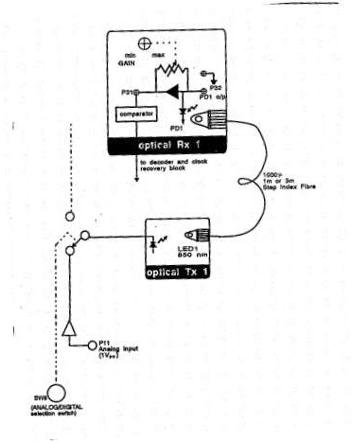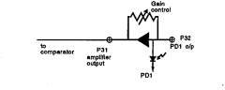

**Figure 1: Gain control**

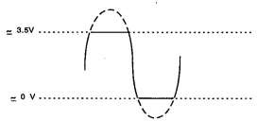

**Figure 2: Signal at P31**

**Model Graph**

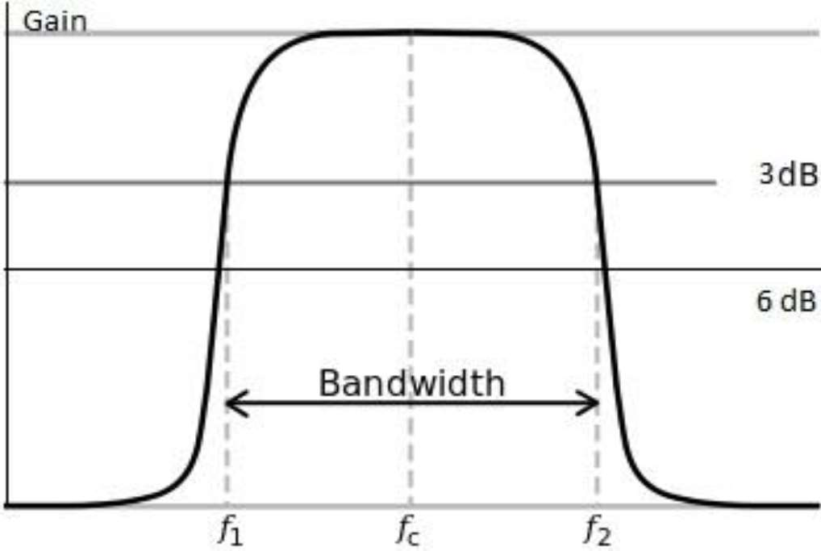

## TABULATION:

## POSTLAB QUESTIONS:

1. What is Optical Bandwidth and Electrical Bandwidth? Give their relation.
2. What is the maximum bandwidth the analog link can support?
3. What are the important blocks of point-to-point links?
4. What is the function of Optical receiver?
5. Calculate link loss (LL) for a 2-km-long multimode link with a power budget (PB) of 13 dB having five connectors and two splices for the following parameters:

Fiber attenuation = 1 dB/km Loss in connector = 0.5 dB Loss in splice = 0.5 dB

Higher-order mode loss = 0.5 dB Clock recovery module = 1 dB

Also find the link has sufficient power for transmission or not?

## RESULT:

Hence, the Analog link is established in fiber optic link.

## EXP NO: 8(B) SETTING UP A FIBER OPTIC DIGITAL LINK

**OBJECTIVE**:

1. To set up 650 nm and 850 nm digital link.
2. To measure the maximum bit rates supportable on the links.

## HARDWARE REQUIRED:

Optical fiber trainer kit, Two channel 20 MHz oscilloscope, Function generator (1Hz – 10MHz)

## INTRODUCTION:

The OFT can be used to set up two fiber optic digital links, one at a wavelength of 650 nm and the other at 850 nm. LED 1, in the optical TX1 block, is an 850 nm LED, and LED 2, in the optical TX2 block, is a 650 nm LED.

PD1, in the optical RX1 block, is a PIN detector which gives a current proportional to the optical power falling on the detector. The received signal is amplified and converted to a TTL signal using a comparator. The GAIN control plays a crucial role in this conversion.

PD2, in the optical RX2 block, is another receiver which directly gives out a TTL signal. Both the PIN detectors can receive 650nm as well a 850nm signals, though their sensitivity is lower at 650nm.

## PRELAB QUESTIONS:

1. What is a TTL signal?
2. Compare Analog and Digital transmitter
3. Define sensitivity
4. What are the modulation formats used in optical Communication
5. What is a Trans impedance receiver.

## LAYOUT DIAGRAM:

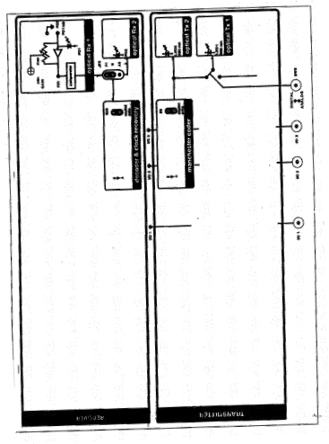

**PROCEDURE:**

1. Set the switch SW8 to the digital position.
2. Connect a 1m optical fiber between LED1 and the PIN diode PD1.
3. Ensure that the shorting plug of jumper JP2 is across the posts B &A1.
4. Feed a TTL signal of about 20 KHz from the function generator to post B of S6. Observe the received analog signal at the amplifier post P31 on channel 1 of the oscilloscope. Note the signal at P31 gets cutoff above 3.5V. Increase and decrease the Gain and observe the effect.
5. Observe the received signal at post A of S26 on channel 2 of the oscilloscope while still observing the signal at P31 on channel 1.
6. Set the gain such the signal at P31 is about 2 V. Observe the input signal from the

function generator on channel 1 and the received TTL signal at post A of S26 on channel 2. Vary the frequency of the input signal and observe the output response.

1. Repeat steps 4, 5, and 6 with 3 m fiber.

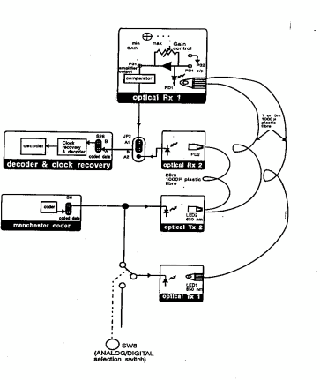

## COMPARATOR TO CONVERT RECEIVED SIGNAL INTO A TTL SIGNAL:

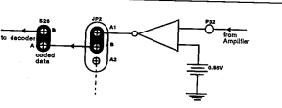

## POSTLAB QUESTIONS:

1. What is a Digital Link?
2. What are the advantages of digital link over analog link?
3. What is a high impedance receiver?
4. A digital optical fiber communication system operating at a wavelength of 1 μm requires a maximum bit error rate of 10-9. What is the theoretical quantum limit at the receiver in terms of the quantum efficiency of the detector and the energy of an incident photon?

## RESULT:

Hence, the Digital link is established in fiber optic link